Risks Associated with Tdap  There are minimal risks associated with the vaccination. It is estimated that only one in one million doses will result in a severe allergic reaction. The side effects of the Tdap vaccination are usually mild to moderate and subside on their own. These effects include: pain, redness, swelling, fever, headache, tiredness, nausea, vomiting, diarrhea, stomachache, chills, body aches, sore joints, rash, and swollen glands.  According to the Vaccine Adverse Event Reporting System, no safety signals have been found among pregnant women or their babies after Tdap vaccination. |  |  | Clinical Complications of Pertussis  Pertussis can result in serious and potentially life-threatening complications in infants and young children who are not fully vaccinated. Possible clinical complications include: apnea, pneumonia, seizures, encephalopathy, anorexia, dehydration, difficulty sleeping, epistaxis, hernias, otitis media, urinary incontinence, pulmonary hypertension, pneumothorax, rectal prolapse, subdural hematomas, and death. |  |  | 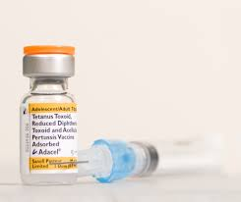  Tdap vaccine (tetanus, diptheria, & Pertussis)  - Dana Burns, RN, BSN Primary Care Nurse Practitioner Student Auburn University/Auburn Montgomery

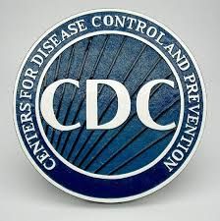  What is Pertussis?  Pertussis, also known as whooping cough, is a highly contagious respiratory infection caused by the bacterium Bordetella pertussis.  How is it transmitted? Pertussis is transmitted by direct contact with mucus or droplets from the nose and throat of infected individuals. |  |  | How to Prevent Pertussis  The best way to prevent infants from becoming infected with pertussis is by administering the Tdap vaccine to pregnant women between the 27th and 36th week of gestation.  Administering the vaccine during the third trimester optimizes the transfer of maternal pertussis antibodies in early life, before infants are able to receive the primary DTaP series  In October 2012, the Advisory Committee on Immunization Practices (ACIP), in response to a sudden resurgence in pertussis cases in the United States, voted to administer the vaccination during the third trimester of each pregnancy regardless of prior immunization history. |  |  | What is Tdap?  Tdap is a combination vaccine that protects against tetanus, diphtheria, and pertussis.  Who Should Not Get Vaccinated?  If an individual has had a life-threatening reaction, coma, or seizures following a vaccination containing the tetanus, diphtheria, or pertussis vaccine they should not get the vaccination. Individuals who have epilepsy or other nervous system problem, had pain or swelling following a vaccination containing any of the components of Tdap, ever had Guillain-Barré Syndrome, or are not feeling well on the day of the immunization should consult with their health care provider before receiving the vaccine

